**Data to be used for “Giving London a more South African Flavour”**

I will use the following sites to source data from which I can make an accurate decision:

<https://foursquare.com/explore?mode=url&ne=51.625264%2C0.140419&q=Food&sw=51.361492%2C-0.435677>

E.g.

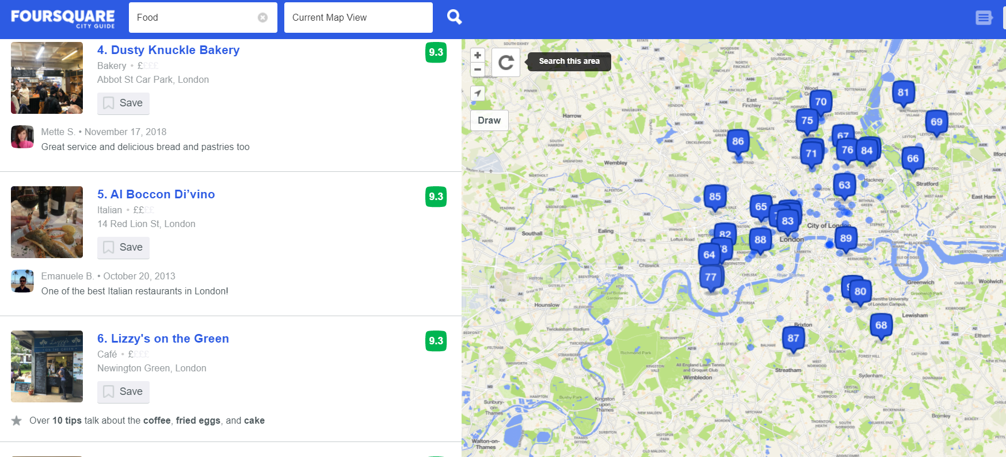

The above foursquare data shows a list of London restaurants and their location.

I will also make use of this Wikipedia list to supplement the above list:

<https://en.wikipedia.org/wiki/List_of_restaurants_in_London>

E.g.

